|  |
| --- |
| CS633 – Distributed Software Engineering |
| DefTrack |
| Software Defect Tracking Solution |

|  |
| --- |
|  |

Table of Contents

Introduction 2

Project Team 2

Deliverables Schedule and Oversight 3

Team Collaboration Tools 3

Pivotal Tracker 3

GitHub 4

GoToMeeting 5

Email 5

Deliverables 5

Week One 5

Week Two 5

Week Three 5

Week Four 6

Week Five 6

DefTrack Software Solution 6

Home Page: 6

Record New Defect 6

Work Queue Summary Page 7

Project Manager Queue 8

Lead Developer Queue 9

Developer Queue 9

Quality Control Queue 9

Customer Acceptance / Closed Queue 9

Conclusion 9

# Introduction

Team 3 elected to develop a Defect Tracking syste, called DefTrack. DefTrack is a workflow-based defect tracking system that supports a business’ needs in recording, tracking, resolving, and reporting defects.

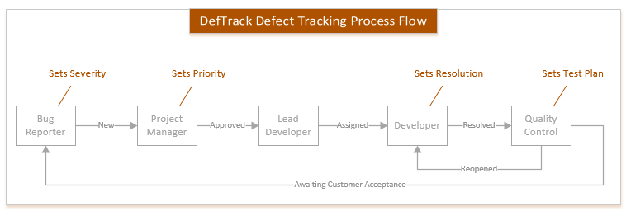

# Project Team

Project Manager: Ivan Justiniano

Business Analyst: Nam Tran

Technical Design/Architect: Stephen Mulcahy

Developer: Keith Bennett

The Project Team worked well together. With no real software programmer on the team, the team worked hard to insure direction and vision were established, deliverables were completed ahead of schedule and all contributed on peer reviews to insure a solid solution was being orchestrated.

# Deliverables Schedule and Oversight

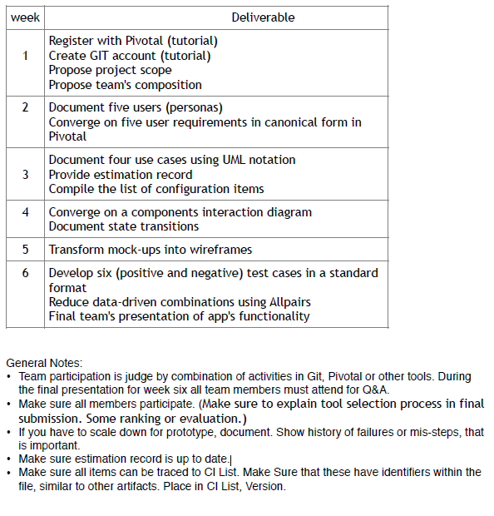

# Team Collaboration Tools

## Pivotal Tracker

The team has setup Pivotal Tracker to be utilized as the primary tool for overseeing the project. The system is primarily managed by the team’s project manager, with the contributions and collaborations of the team. This is the primary location for storage of the class deliverables.

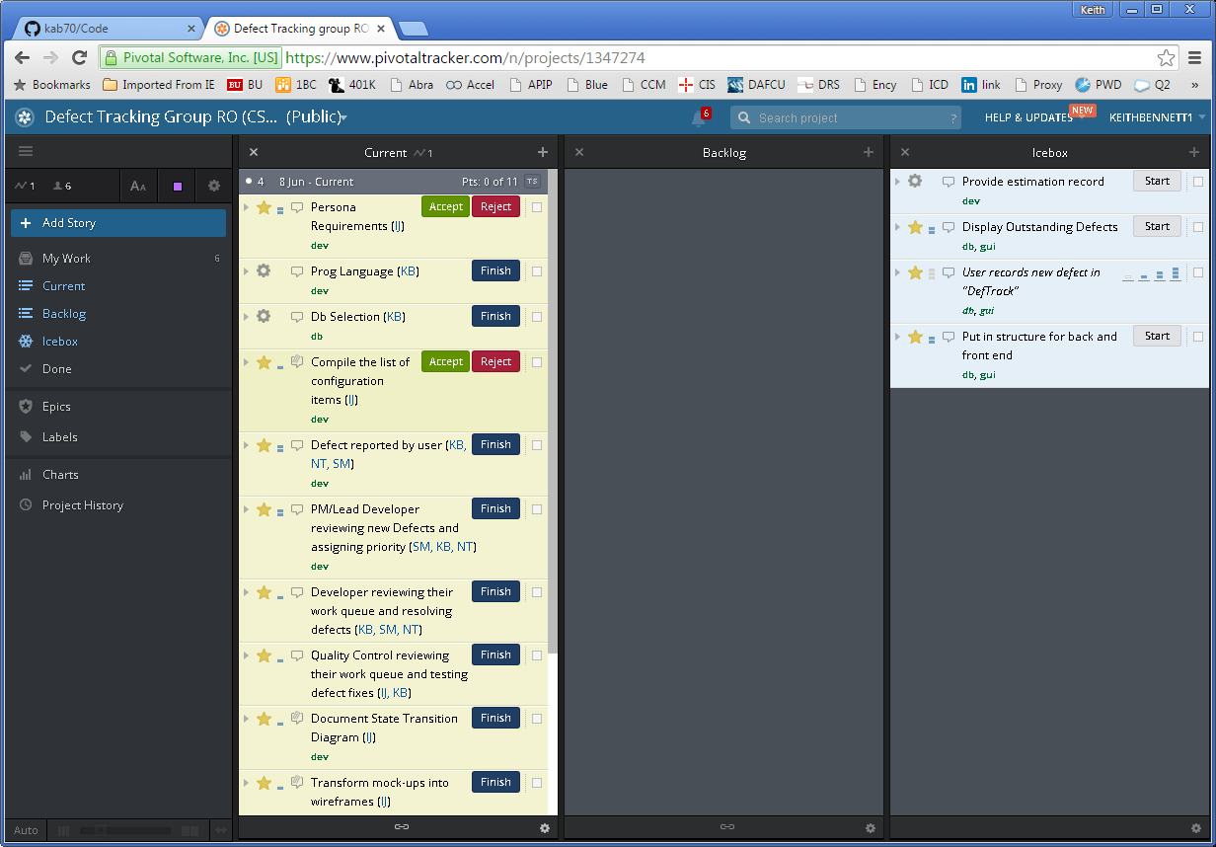

## GitHub

The team established a GitHub repository. The team elected to utilize GitHub for the primary use of handling versioning control of the DefTrack software system.

GitHub stores a total of six commits and one release of the DefTrack software system.

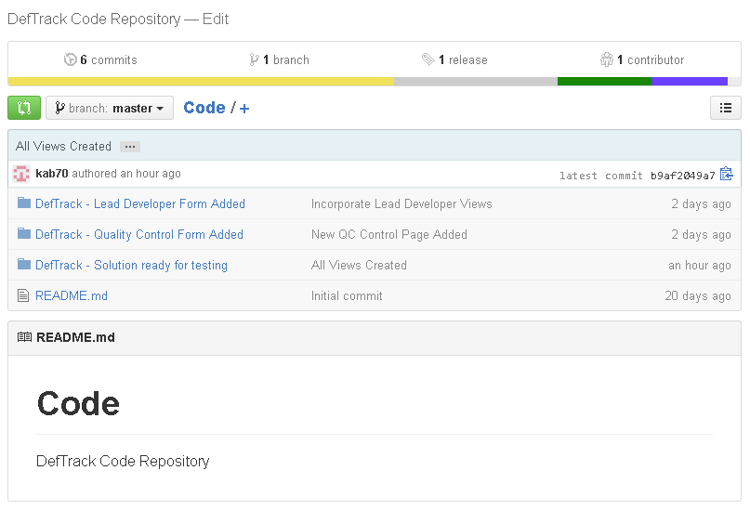

## GoToMeeting

For team collaboration, clarification, and work allocation, the team utilized GoToMeeting. One hour meetings were scheduled for Tuesdays and Saturdays.

## Email

Throughout the project, team members were kept current through the utilization of group e-mail.

# Deliverables

## Week One

Screen shots

## Week Two

Screen shots

## Week Three

Screen shots

## Week Four

Screen Shots

## Week Five

Screen shots

# DefTrack Software Solution

## Home Page:

The Home page was the default page where users are able to Register/Log In to DefTrack and then submit a new defect, access the Work Queue, or go into the Administration console (which was outside of initial project scope).

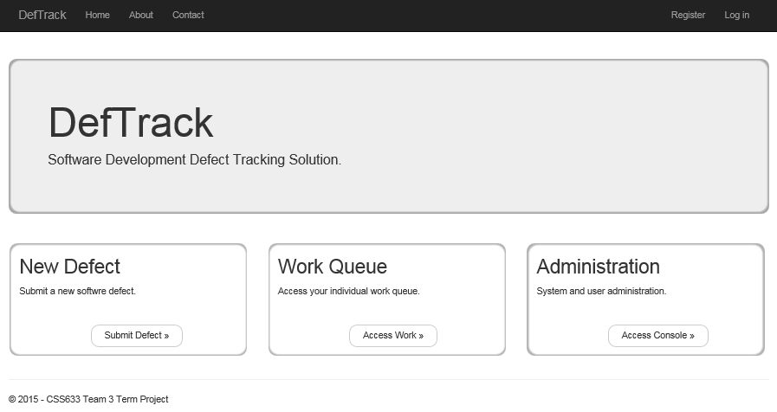

## Record New Defect

Once users is logged into the DefTrack system, they are able to click on the “Submit Defect >>” button which opens the NewDefect form.

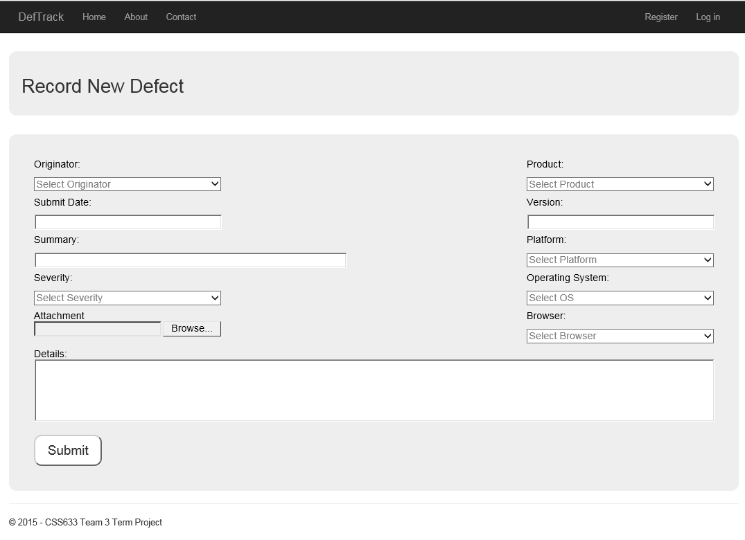

Once user submits a new defect, they receive an acknowledgment screen that provides them with the Defect ID that has been assigned to the submission.

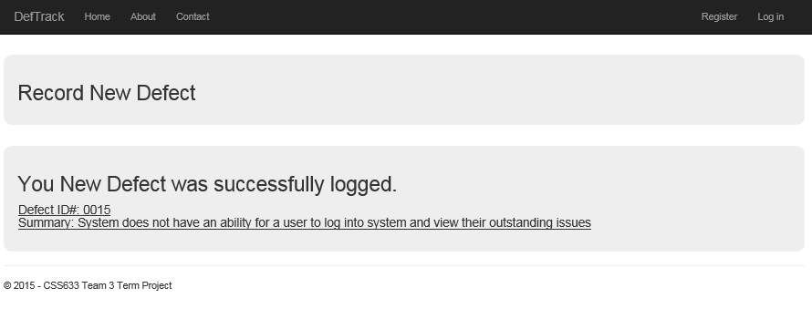

## Work Queue Summary Page

The Work Queue Summary page lists all defects that a project team would be working on.

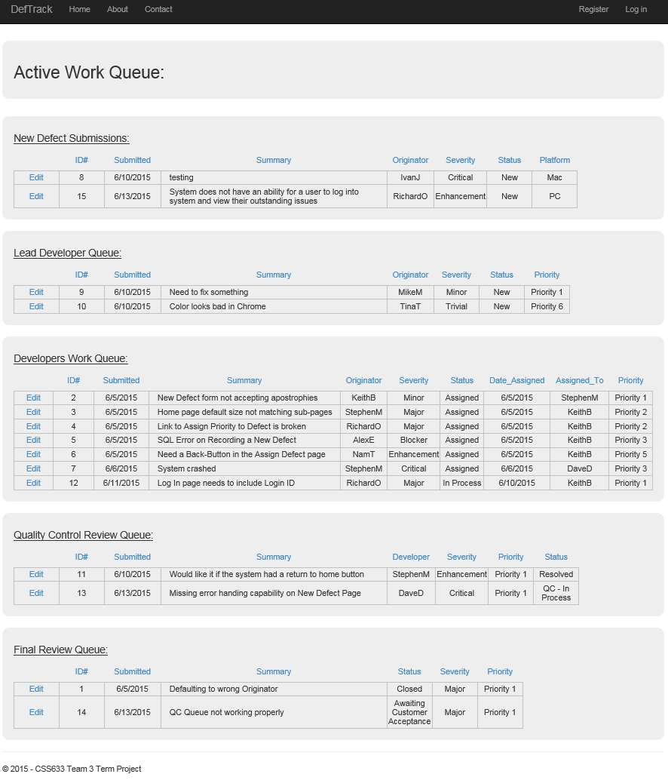

## Project Manager Queue

Image to come

## Lead Developer Queue

Image to come

## Developer Queue

Image to come

## Quality Control Queue

Image to come

## Customer Acceptance / Closed Queue

Image to come

# Conclusion